Exp19.Create A Storage Service Using Any Public Cloud Service Provider (Azure/Gcp/Aws) And Check The Public Accessibility Ofthe Stored File To Demonstrate Storage As A Service.

Aim:
To Create A Storage Service Using Any Public Cloud Service Provider (Azure/Gcp/Aws) And Check The Public Accessibility Ofthe Stored File To Demonstrate Storage As A Service.

Procedure:
Step1: Open Azure And Goto Storage Accounts And Createstoroage Account
Step2: Enter The Resourc Groupand And Storage Account Nameand Review And Create And Click Th Create And Your Storage Account Will Be Deployed Sucessfully.
Step3: Our Storage Account Is Created.
Step4: Goto Static Website
Step5: And Enable And Enter Your Index And Error Html Files Names.
Step6: And Goto Storage Explorr(Review) And And Goto Blobcontainers And Web And Upload The Two Html Files Init
Step7: And Again Return To Static Website And Open The Primarylink And Your Web Page Is Created


Exp20.Create A Sql Storage Service And Perform A Basic Query Usingany Public Cloud Service Provider (Azure/Gcp/Aws) To Demonstrate Database As A Service (Daas)

Aim: Create A Sql Storage Service And Perform A Basic Query Usingany Public Cloud Service Provider (Azure/Gcp/Aws) To Demonstrate Database As A Service (Daas)

Procedure:
Step1: Goto Azure And Goto Sqldatabase.
Step 02: Now Create A Sql Databse
Step3: Select The Resource Groupand Enter The Servernamethat Applicable.
Step4: In Networking Select Allow Azure Services And Resources To Access This Server.
Step5: In Additional Settings Select Sample.

Step6:And The Sql Database Is Deployed
Tep7: Now Goto Query Editor.
Step8:Now Again Login To The Sqldatadatabase
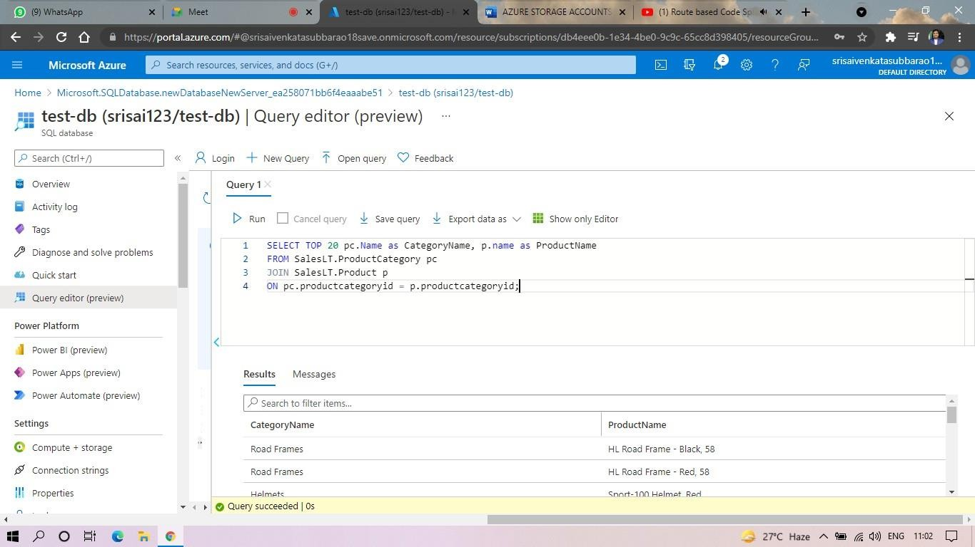

Exp. 22: Perform The Basic Configuration Setup For Installinghadoop 2.X Like Creating The Hduser And Ssh Localhost

Aim: Perform The Basic Configuration Setup For Installinghadoop 2.X Like Creating The Hduser And Ssh

Procedure:

Install Java Development Kit (JDK) and verify the installation using:

java -version

Create a Hadoop group:

sudo addgroup hadoop

Create a Hadoop user named hduser:

sudo adduser --ingroup hadoop hduser

Switch to the hduser account:

su - hduser

Install SSH:

sudo apt-get install ssh

Generate an SSH key pair:

ssh-keygen -t rsa -P ""

Add the generated public key to authorized keys:

Test SSH localhost login:

ssh localhost

Download and extract the Hadoop 2.X package:

tar -xzf hadoop-2.x.x.tar.gz

Configure Hadoop environment variables in the .bashrc file.

Reload the configuration:

source ~/.bashrc

Verify Hadoop installation:

hadoop version

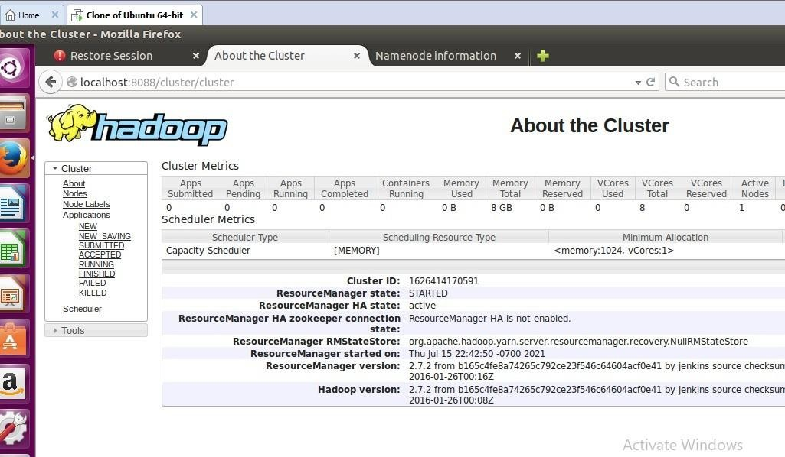

Exp. 23: Install Hadoop 2.X And Configure The Name Node And Datanode.

Aim: Install Hadoop 2.X And Configure The Name Node And Datanode.

Procedure: Procedure:
- Install Hadoop 2.X on the system.
- Configure the Hadoop environment variables.
- Set the Java Home path in the Hadoop configuration files.
- Edit the core-site.xml file and specify the Hadoop file system settings.
- Edit the hdfs-site.xml file and configure the NameNode and DataNode properties.
- Create separate directories for NameNode and DataNode storage.
- Save the configuration files and apply the changes.
- Format the NameNode to initialize the Hadoop Distributed File System (HDFS).
- Start the HDFS services.
- Verify the running status of NameNode and DataNode services.
- Check the Hadoop web interface for cluster information.
- Test the HDFS functionality by creating directories and uploading files.
- Verify successful communication between NameNode and DataNode.
- Monitor the Hadoop processes and ensure proper operation.
- Confirm that Hadoop 2.X installation and configuration are completed successfully.
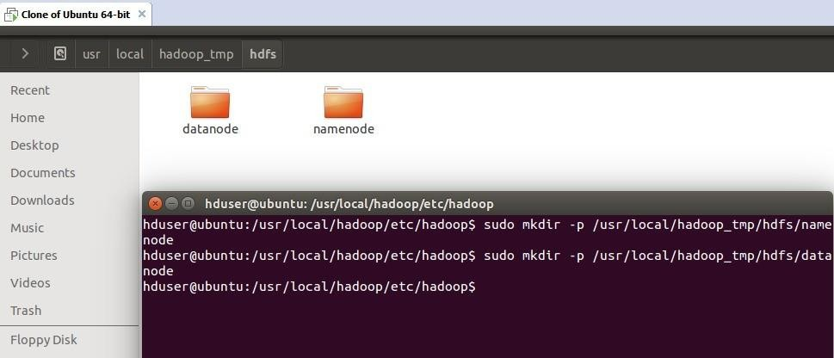

Exp. 24: Launch The Hadoop 2.X And Perform Mapreduce Programfor A Word Count problem

Aim: Launch The Hadoop 2.X And Perform Mapreduce Programfor A Word Count Problem

Procedure:
- Download and extract the Hadoop 2.X package.
- Set Hadoop environment variables in the .bashrc file.
- Reload the environment variables using the source command.
- Open the hadoop-env.sh file and configure the Java Home path.
- Edit the core-site.xml file and set the default file system configuration.
- Edit the hdfs-site.xml file and configure the NameNode and DataNode directories.
- Create separate directories for storing NameNode and DataNode data.
- Save all configuration files.
- Format the NameNode using the Hadoop format command.
- Start the Hadoop Distributed File System (HDFS) services.
- Verify that the NameNode and DataNode services are running properly.
- Open the Hadoop web interface and check the cluster status.
- Confirm successful communication between the NameNode and DataNode.
- Verify the installation using Hadoop commands and process monitoring tools.
- Ensure that Hadoop 2.X is configured and functioning correctly.

